Lab task 08 by 21SW159

1. Write a java program based on filing. Perform Create, Read and Write operations on JSON file.

**Code:**

**package** swmuet;  
**import** java.io.FileWriter;  
**import** java.io.IOException;  
**import** org.json.simple.JSONObject;  
**public class** Main {  
 **public static void** main(String args[]) {  
 *//Creating a JSONObject object* JSONObject jsonObject = **new** JSONObject();  
 *//Inserting key-value pairs into the json object* jsonObject.put(**"ID"**, **"1"**);  
 jsonObject.put(**"First_Name"**, **"Shikhar"**);  
 jsonObject.put(**"Last_Name"**, **"Dhawan"**);  
 jsonObject.put(**"Date_Of_Birth"**, **"1981-12-05"**);  
 jsonObject.put(**"Place_Of_Birth"**, **"Delhi"**);  
 jsonObject.put(**"Country"**, **"India"**);  
 **try** {  
 FileWriter file = **new** FileWriter(**"F:/output.json"**);  
 file.write(jsonObject.toJSONString());  
 file.close();  
 } **catch** (IOException e) {  
 *//* ***TODO Auto-generated catch block*** e.printStackTrace();  
 }  
 System.out.println(**"JSON file created: "**+jsonObject);  
 }  
 }

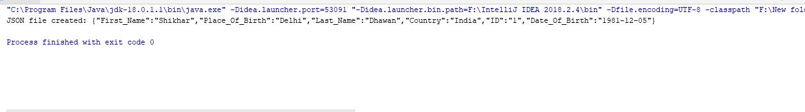**Output:**

1. Write a java program based on filing. Perform Create, Read and Write operations on text file using BufferedReader and BufferedWriter Class.

**Code:**

import java.io.BufferedReader;

import java.io.BufferedWriter;

import java.io.File;

import java.io.IOException;

import java.io.FileWriter;

class Practice2 {

public static void main(String[] args) {

try{

File Newfile = new File("outpt.txt");

BufferedWriter writer = new BufferedWriter(new FileWriter("outpt.txt"));

Newfile.createNewFile();

writer.write("welcome to the other side");

writer.close();

BufferedReader reader = new BufferedReader(new FileReader("outpt.txt"));

int i;

while((i=reader.read())!=-1){

System.out.print((char)i);

}

reader.close();

}

catch (Exception e) {

System.out.println(e);

}

}

}

**Output:**



1. Write a program that opens a file in write mode(use file modes), takes name and roll no from the students write it in the file and closes the file.

**Code:**

import java.io.File;

import java.io.IOException;

import java.io.*;

import java.io.FileWriter;

import java.util.Scanner;

class Practice2 {

public static void main(String[] args) {

try{

File myFile = new File("C:/Users/Ahsan/Desktop/output.txt","w");

Scanner scan = new Scanner(System.in);

String name=scan.nextLine();

String rollNo=scan.nextLine();

myFile.createNewFile();

FileWriter file = new FileWriter("output.txt");

file.write("Name: "+name+"\nRoll no: "+rollNo+'\n');

file.close();

}

catch(Exception e){

System.out.print(e);

}

}

}

**Output:**

